The Hope of Christmas: Jesus’s Role as Rescuer and Redeemer
The Advent Storybook: 25 Bible Stories Showing Why Jesus Came presents a family-friendly depiction of Eden, the Fall, Jesus’ birth, and so many important stories in between. Perfect for the Advent season leading to Christmas, The Advent Storybook includes beautiful illustrations by accomplished artist Ian Dale to accompany each of the twenty-five stories.
Author and mom, Laura Richie, originally created the storybook for her own three children, to highlight God’s role as Rescuer in each of their lives. After writing the book, she felt God prompting her to publish it and make the story of His rescue available for other children and families, as well. The Advent Storybook is set to release from David C Cook on October 1, 2018.
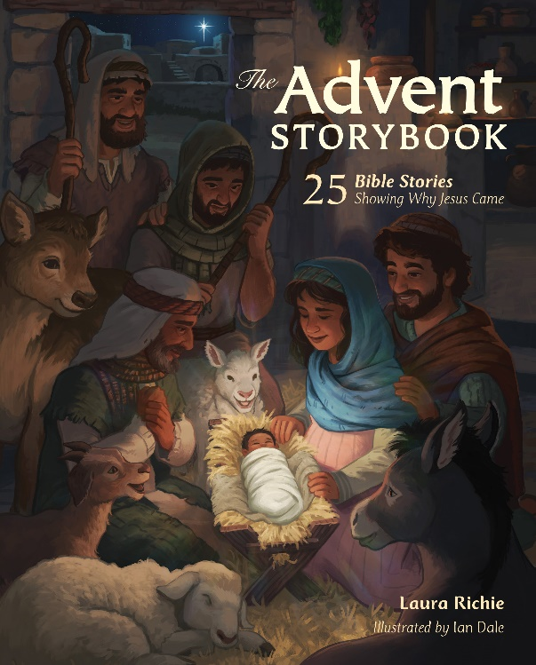
About her book, Richie says, “In the beginning, God made everything good—there was no evil, suffering, or death. But a terrible enemy crept into the Garden of light, laughter, and life. When people believed his lies, everything shattered. All seemed lost. But the Creator spoke a promise: One day, a Son would come to make all things good and new again! The birth of Jesus, the Promised Son, is the reason we celebrate Christmas!”
Written for children ages 4-8, the book includes a story for each day of December leading up to Christmas—a perfect reminder of God’s rescue and redemption in preparation for the celebration of Christ’s first coming.
Color, lighting, and body language are utilized in the detailed illustrations to paint a clearer image of the dark stages of suffering as well as the lightness of hope God’s people experienced from the Garden of Eden to the first Christmas. Each of the twenty-five entries begins with a key verse and ends with a thoughtful question for families to discuss during the holiday season.

The Advent Story Book: 25 Bible Stories Showing Why Jesus Came
By Laura Richie, Illustrated by Ian Dale
ISBN: 978-0830776085
$13.99
Hardcover
Release: October 1, 2018

About the Author: Laura Richie

Laura Richie is a wife, homeschooling mom to three, and a registered nurse. Formerly a missionary kid, Laura didn’t truly understand her need to be rescued until later in life. For years, she had tried very hard to be “good enough.” When she finally realized that Jesus came because she could never be good enough on her own, her striving ceased and her dancing began! Now she delights in sharing the beauty and grace of her Rescuer. Laura and her family reside in Oklahoma.

After writing The Advent Storybook for her own children, Laura felt called to publish the book and share the story of God’s rescue with families across the world.
https://adventstorybook.com/about-the-author/

About the Illustrator: Ian Dale

Ian is an illustrator and designer for children's media. As an art student he came to faith in the promised rescuer, and his world was turned upside down! Ian loves to invest himself in projects that share the hope and meaning that have transformed his own life. He has created biblically-oriented illustrations for clients such as World Vision, The American Bible Society, Compassion International, Deep Blue Kids, and OneHope. Ian was an artist for the Bible App for Kids, an interactive storybook app downloaded millions of times in over 30 languages. He and his wife have a one-year-old daughter.
www.iandale.net

Suggested Interview Questions for Laura Richie

- How can we all celebrate the true meaning of Christmas?

- You originally wrote this book for your children. What was the primary message you hoped to give them?

- Why did you decide to bring the book to a larger audience?

- Which major biblical figures are covered in the book? Why did you choose them?

- Is The Advent Storybook suitable for a specific age-range? How can this book help parents start conversations with their kids about Jesus?

- The book’s illustrations by Ian Dale are gorgeous. How do they help tell the story?

- You mention on your website that it was important for you to create a historically accurate storybook. How did you go about doing this?

- Do you have a favorite story in the book? Which story is a favorite of your kids?

- Where can people go to learn more about The Advent Storybook?

